COURSE CODE: CSA1273

COURSE NAME: Computer Architecture for Emerging technologies

NAME: J. brahmaiah

REGISTER NUMBER:192472286



By supervisor,

Dr.P. Suresh Sir

**8-BIT ADDITION**

**EXP NO: 1**

**AIM:**

To write an assembly language program to implement 8-bit addition using 8085 processor.

**ALGORITHM:**

1) Start the program by loading the first data into the accumulator.

2) Move the data to a register.

3) Get the second data and load it into the accumulator.

4) Add the two register contents.

5) Check for carry.

6) Store the value of sum and carry in the memory location.

7) Halt.

**PROGRAM:**

**LDA 8050**

**MOV B, A**

**LDA 8051**

**ADD B**

**STA 8052**

**HLT**

**INPUT:**

|  |  |
| --- | --- |
| **ADDRESS** | **DATA** |
| 8050 | 1 |
| 8051 | 2 |

**OUTPUT:**

|  |  |
| --- | --- |
| **ADDRESS** | **DATA** |
| 8052 | 3 |

**RESULT:** Thus the program was executed successfully using 8085 processor simulator.

**8-BIT SUBTRACTION**

**EXP NO: 2**

**AIM:** To write an assembly language program to implement 8-bit subtraction using 8085 processor.

**ALGORITHM:**

1) Start the program by loading the first data into the accumulator.

2) Move the data to a register.

3) Get the second data and load it into the accumulator.

4) Subtract the two register contents.

5) Check for borrow.

6) Store the difference and borrow in the memory location.

7) Halt.

**PROGRAM:**

**LDA 8000**

**MOV B, A**

**LDA 8001**

**SUB B**

**STA 8002**

**HLT**

**INPUT:**

|  |  |
| --- | --- |
| **ADDRESS** | **DATA** |
| 8000 | 4 |
| 8001 | 5 |

**OUTPUT:**

|  |  |
| --- | --- |
| **ADDRESS** | **DATA** |
| 8002 | 1 |

**RESULT:** Thus, the program was executed successfully using 8085 processor simulators

**8-BIT MULTIPLICATION**

**EXP NO: 3**

**AIM:** To write an assembly language program to implement 8-bit multiplication using 8085 processor.

**ALGORITHM:**

1) Start the program by loading a register pair with the address of memory location.

2) Move the data to a register.

3) Get the second data and load it into the accumulator.

4) Add the two register contents.

5) Increment the value of the carry.

6) Check whether the repeated addition is over.

7) Store the value of product and the carry in the memory location.

8) Halt.

**PROGRAM:**

**LDA 2200**

**MOV E, A**

**MVI D, 00**

**LDA 2201**

**MOV C, A**

**LXI H, 0000**

**BACK: DAD D**

**DCR C**

**JNZ BACK**

**SHLD 2202**

**HLT**

**INPUT:**

|  |  |
| --- | --- |
| **ADDRESS** | **DATA** |
| 2200 | 4 |
| 2201 | 2 |

**OUTPUT:**

|  |  |
| --- | --- |
| **ADDRESS** | **DATA** |
| 2202 | 8 |

**RESULT:** Thus, the program was executed successfully using 8085 processor simulators.

**8-BIT DIVISION**

**EXP NO: 4**

**AIM:** To write an assembly language program to implement 8-bit division using 8085 processor.

**ALGORITHM:**

1) Start the program by loading a register pair with the address of memory location.

2) Move the data to a register.

3) Get the second data and load it into the accumulator.

4) Subtract the two register contents.

5) Increment the value of the carry.

6) Check whether the repeated subtraction is over.

7) Store the value of quotient and the reminder in the memory location.

8) Halt.

**PROGRAM:**

**NOP**

**LDA 8500**

**MOV B, A**

**LDA 8501**

**MVI C, 00H**

**LOOP: CMP B**

**JC LOOP1**

**SUB B**

**INR C**

**JMP LOOP**

**LOOP1: STA 8502**

**MOV A, C**

**STA 8503**

**RST 1**

**HLT**

**INPUT:**

|  |  |
| --- | --- |
| **ADDRESS** | **DATA** |
| 8500 | 2 |
| 8501 | 6 |

**OUTPUT:**

|  |  |
| --- | --- |
| **ADDRESS** | **DATA** |
| 8502 | 0 |
| 8503 | 3 |

**RESULT:** Thus the program was executed successfully using 8085 processor simulator.

**16-BIT ADDITION**

**EXP NO: 5**

**AIM: -**

To write an assembly language program to implement 16-bit addition using 8085 processor.

**ALGORITHM: -**

1) Start the program by loading a register pair with address of 1st number.

2) Copy the data to another register pair.

3) Load the second number to the first register pair.

4) Add the two register pair contents.

5) Check for carry.

6) Store the value of sum and carry in memory locations.

7) Terminate the program.

**PROGRAM: -**

**LDA 3050**

**MOV B, A**

**LDA 3051**

**ADD B**

**STA 3052**

**LDA 3053**

**MOV B, A**

**LDA 3054**

**ADC B**

**STA 3055**

**HLT**

**INPUT:-**

|  |  |
| --- | --- |
| Address | Data |
| 3050 | 2 |
| 3051 | 3 |
| 3053 | 5 |
| 3054 | 5 |

**OUTPUT: -**

|  |  |
| --- | --- |
| Address | Data |
| 3052 | 5 |
| 3055 | 10 |

**RESULT: -**

Thus, the program was executed successfully using 8085 processor simulators.

**16-BIT SUBTRACTION**

**EXP NO: 6**

**AIM: -**

To write an assembly language program to implement 16-bit subtraction using 8085 processor.

**ALGORITHM: -**

1) Start the program by loading a register pair with address of 1st number.

2) Copy the data to another register pair.

3) Load the second number to the first register pair.

4) sub the two register pair contents.

5) Check for carry.

6) Store the value of sum and carry in memory locations.

7) End.

**PROGRAM: -**

**LHLD 2050**

**XCHG**

**LHLD 2052**

**MOV A, L**

**SUB E**

**STA 2054**

**MOV A, H**

**SBB D**

**STA 2055**

**HLT**

**INPUT: -**

|  |  |
| --- | --- |
| Address | Data |
| 2050 | 2 |
| 2052 | 3 |

**OUTPUT: -**

|  |  |
| --- | --- |
| Address | Data |
| 2054 | 1 |
| 2055 | 1 |

**RESULT: -**

Thus, the program was executed successfully using 8085 processor simulators.

**16-BIT MULTIPLICATION**

**EXP NO: 7**

**AIM: -**

To write an assembly language program to implement 16-bit multiplication using 8085 processor.

**ALGORITHM: -**

1) Load the first data in HL pair.

2) Move content of HL pair to stack pointer.

3) Load the second data in HL pair and move it to DE.

4) Make H register as 00H and L register as 00H.

5) ADD HL pair and stack pointer.

6) Check for carry if carry increment it by 1 else move to next step.

7) Then move E to A and perform OR operation with accumulator and register D.

8) The value of operation is zero, then store the value else go to step

**PROGRAM: -**

**LHLD 2050**

**SPHL**

**LHLD 2052**

**XCHG**

**LXI H,0000H**

**LXI B,0000H**

**AGAIN: DAD SP**

**JNC START**

**INX B**

**START: DCX D**

**MOV A, E**

**ORA D**

**JNZ AGAIN**

**SHLD 2054**

**MOV L, C**

**MOV H, B**

**SHLD 2055**

**HLT**

**INPUT: -**

|  |  |
| --- | --- |
| Address | Data |
| 2050 | 10 |
| 2052 | 5 |

**OUTPUT: -**

|  |  |
| --- | --- |
| Address | Data |
| 2054 | 50 |
| 2055 | 5 |

**RESULT: -**

Thus, the program was executed successfully using 8085 processor simulators.

**16-BIT DIVISION**

**EXP NO: 8**

**AIM: -**

To write an assembly language program to implement 16-bit division using 8085 processor.

**ALGORITHM: -**

1) Read dividend (16 bit)

2) Read divisor

3) count <- 8

4) Left shift dividend

5) Subtract divisor from upper 8-bits of dividend

6) If CS = 1 go to 9

7) Restore dividend

8) Increment lower 8-bits of dividend

9) count <- count - 1

10) If count = 0 go to 5

11) Store upper 8-bit dividend as remainder and lower 8-bit as quotient

12) Stop

**PROGRAM: -**

**LDA 8500**

**MOV B, A**

**LDA 8501**

**MVI C,00**

**LOOP: CMP B**

**JC LOOP1**

**SUB B**

**INR C**

**JMP LOOP**

**LOOP1: STA 8502**

**MOV A,C**

**STA 8503**

**HLT**

**INPUT: -**

|  |  |
| --- | --- |
| Address | Data |
| 8051 | 20 |
| 8050 | 2 |

**OUTPUT: -**

|  |  |
| --- | --- |
| Address | Data |
| 8502 | 10 |
| 8503 | 2 |

**RESULT: -**

Thus, the program was executed successfully using 8085 processor simulators

# 

# 16-BIT ADDITION

# EXP NO: 9

**AIM: -** To write an assembly language program to implement 16-Bit addition using 8086 processor.

# ALGORITHM: -

1. Start the program by loading a register pair with address of 1st number.
2. Copy the data to another register pair.
3. Load the second number to the first register.
4. Add the two register pair contents.
5. Check for carry.
6. Store the value of sum and carry in memory location. Result stored in AX. 7-Terminate the program.

# PROGRAM:

**MOV AX, [1100H]**

**MOV BX, [1102H]**

**ADD AX, BX**

**MOV [1200H], AX**

**HLT**

**INPUT :-**

|  |  |  |
| --- | --- | --- |
| **REGISTER** | **MEMORY** | **DATA** |
| AX | 32 | 1100 |
| BX | 45 | 1102 |

**OUTPUT:-**

|  |  |  |
| --- | --- | --- |
| **REGISTER** | **MEMORY** | **DATA** |
| AX | 77 | 1200 |

**RESULT: -** Thus, the program was executed successfully using 8086 process simulators.

**16 BIT SUBTRACTION**

**EXP NO: 10**

**AIM:**

To write an assembly language program to implement 16-bit subtraction using 8086 processor.

**ALGORITHM:**

1] Start the program by loading a register pair with address of first number.

2] Copy the data to another register pair.

3] Laod the second number to first register pair.

4] Subtract the two register pair contacts.

5] Check for borrow.

6] Store the value of difference and borrow in memory location.

7] End.

**PROGRAM:**

**MOV AX,[1100H]**

**MOV BX,[1102H]**

**SUB AX,BX**

**MOV [1200H], AX**

**HLT**

**INPUT:**

|  |  |
| --- | --- |
| **ADDRESS** | **DATA** |
| 1100 | 30 |
| 1102 | 15 |

**OUTPUT:**

|  |  |
| --- | --- |
| **ADDRESS** | **DATA** |
| 1200 | 15 |

**RESULT:**

Thus, the program was executed successfully using 8086 processor simulators.

**16-bit multiplication**

**EXP NO: 11**

**Aim:** To write an assembly language program to implement 16-bit multiplication on 8086 processers.

**ALGORITHM:**

1. Load the first data in HL pair
2. Move content of HL pair to stack pointer
3. Load the second data in the HL pair and move it to DE
4. Make H register as OH and L register OH
5. Add HL pair and stack pointer
6. Check for carry if carry increment by 1 else move to next step
7. Then move E to A and perform or operation with accumulation and register D
8. The value of operation is zero the solve the value else go to step 3

**PROGRAM:**

**MOV AX, [1100H]**

**MOV BX, [1102H]**

**MUL BX**

**MOV [1200H], AX**

**MOV [1202H], DX**

**HLT**

**INPUT:**

|  |  |
| --- | --- |
| **ADDRESS** | **DATA** |
| 1100 | 20 |
| 1202 | 3 |

**OUT PUT:**

|  |  |
| --- | --- |
| **ADDRESS** | **DATA** |
| 1200 | 60 |
| 1202 | 3 |

**RESULT:**

Thus, the program was executed successfully using 8086 emulators.

**16 BIT DIVISION**

**EXP NO: 12**

**AIM:**

To write an assemble language program to implement 16 bits divided using 8086 processor.

**ALGORITHM:**

1] Read dividend (16) bit.

2] Read divisor.

3] Count <-8.

4] Left shift dividend.

5] Subtract divisor from upper 8 bits of dividend.

6] If cs=1 go to 9.

7] Restore dividend.

8] Increment lower 8 bits of dividend.

9] Count <- count -1.

10] If count =0 go to 5.

11] Store upper 8-bit dividend as remainder and lower 8 bit as quotient.

12] Stop.

**PROGRAM:**

**MOV AX, [1100H]**

**MOV BX, [1102H]**

**DIV BX**

**MOV [1200H], AX**

**MOV [1202H], DX**

**HLT**

**INPUT:**

|  |  |
| --- | --- |
| **ADDRESS** | **DATA** |
| 1100 | 10 |
| 1102 | 10 |

**OUTPUT:**

|  |  |
| --- | --- |
| **ADDRESS** | **DATA** |
| 1200 | 1 |
| 1202 | 10 |

**RESULT:**

Thus, the program was executed successfully using 8086 processor simulators.

**Greatest of 2 numbers**

**EXP NO: 13**

**Exp. No: -**

**AIM: -**

To write an Assembly Language Program to find the smallest number in an array using 8085 Microprocessor in GNUSim.

**SOFTWARE USED: -**

GNUSim8085

**ALGORITHM: -**

1. Initialize the count

2. Get the input numbers

3. Compare the content of Accumulator(A) with HL pair for all input numbers

4. Stores the smallest number in the output register

5. End the program

**PROGRAM: -**

**LDA 2050**

**MOV B, A**

**LDA 2051**

**CMP B**

**JNC STORE**

**MOV A, B**

**STORE: STA 2052**

**HLT**

**Input**

|  |  |
| --- | --- |
| Address | Data |
| 2050 | 29 |
| 2051 | 22 |

**Output**

|  |  |
| --- | --- |
| Address | Data |
| 2052 | 29 |

**RESULT:**

Thus the Assembly Language Program to find the smallest number in an array using 8085 Microprocessor in GNUSim is performed.

**Smallest of 2 numbers**

**EXP NO: 14**

**AIM: -**

To write an Assembly Language Program to find the smallest number in an array using 8085 Microprocessor in GNUSim.

**SOFTWARE USED: -**

GNUSim8085

**ALGORITHM: -**

1. Initialize the count

2. Get the input numbers

3. Compare the content of Accumulator(A) with HL pair for all input numbers

4. Stores the smallest number in the output register

5. End the program

**PROGRAM: -**

**LXI H,8050**

**MOV C, M**

**INX H**

**MOV B, M**

**DCR C**

**LOOP: INX H**

**MOV A, M**

**CMP B**

**JNC SKIP**

**MOV B, A**

**SKIP: DCR C**

**JNZ LOOP**

**LXI H,8500**

**MOV M, B**

**HLT**

**Input**

|  |  |
| --- | --- |
| Address | Data |
| 8000 | 10 |

**Output**

|  |  |
| --- | --- |
| Address | Data |
| 8010 | 3 |

**RESULT:**

Thus, the Assembly Language Program to find the smallest number in an array using 8085 Microprocessor in GNUSim is performed.

**SWAPING OF TWO 8-BIT DATA**

**EXP NO: 15**

**AIM:**

To Write an assembly language program to swap two 8-bit data using 8085 processor.

**ALGORITHM:**

1. Load the contents of memory address 1100 into accumulator A.

2. Move the contents of accumulator A into register B.

3. Load the contents of memory address 1101 into accumulator A.

4. Move the contents of accumulator A into register C.

5. Store the contents of accumulator A (which is the original value at 1101) into memory address 1102.

6. Move the contents of register B (which is the original value at 1100) into accumulator A.

7. Store the contents of accumulator A into memory address 1103.

**PROGRAM:**

**LDA 1100**

**MOV B, A**

**LDA 1101**

**MOV C, A**

**STA 1102**

**MOV A, B**

**STA 1103**

**HLT**

**INPUT:**

|  |  |
| --- | --- |
| ADDRESS | DATA |
| 1100 | 6 |
| 1101 | 4 |

**OUTPUT:**

|  |  |
| --- | --- |
| ADDRESS | DATA |
| 1103 | 4 |
| 1104 | 6 |

**RESULT:**

Thus, the program was executed successfully using 8085 processor simulators.

**1’s COMPLIMENT**

**EXP NO: 16**

**AIM:**

To write assembly language to find 1’s COMPLIMENT by using 8085 microprocessor Simulator

**ALGORITHM:**

1. Loads the value from memory address 8000 into accumulator A.

2. Complements the bits of the value in accumulator A using the CMA (Complement Accumulator) instruction. This means that all 1s become 0s and all 0s become 1s.

3. Stores the complemented value into memory address 8001.

4. Halts the program execution.

**PROGRAM:**

**LDA 8000**

**CMA**

**STA 8001**

**HLT**

**INPUT:**

|  |  |
| --- | --- |
| **ADDRESS** | **DATA** |
| **8000** | **6** |

**OUTPUT:**

|  |  |
| --- | --- |
| **ADDRESS** | **DATA** |
| **8001** | **249** |

**RESULT:** thus the program was executed successfully using 8085 processor simulators

**2’S COMPLEMENT**

**EXP NO: 17**

**AIM:**

To write an assembly language program to find 2’s complement of 8-bit number

**ALGORITHM:**

1. Start with the binary number:
2. If the number is positive, simply write its binary equivalent.
3. If the number is negative, begin with the binary equivalent of its positive value.
4. Invert all the bits (1's complement):
5. Flip every 0 to 1 and every 1 to 0
6. Add 1 to the result:
7. Add 1 to the least significant bit (rightmost bit) of the inverted number.
8. The final result is the 2's complement representation of the number.

**PROGRAM:**

**LDA 3000**

**CMA**

**STA 3001**

**ADI 3002**

**HLT**

**INPUT:**

|  |  |
| --- | --- |
| **ADDRESS** | **DATA** |
| **3000** | **8** |

**OUTPUT:**

|  |  |
| --- | --- |
| **ADDRESS** | **DATA** |
| **3001** | **247** |
| **3002** | **0** |

**RESULT:** thus, the program was executed successfully using 8085 processor simulators

**ODD OR EVEN – 8085 MICROPROCESSORS**

**EXP NO: 18**

**AIM:**

To write an assembly language program to find the number is odd or even using 8085 Microprocessor in GNUSim8085

**SOFTWARE USED: -**

GNUSim8085

**ALGORITHM: -**

1. **I**nitialize the number in the accumulator
2. Perform the AND operation with accumulator by 01
3. If the result is ‘0’, it means it is even number (indicates as 22)
4. If the result is non zero, it means the given number is odd (indicates as 11)
5. Stores the out put in the register
6. End the program

**Program: -**

**LDA 8050H**

**ANI 80H**

**JZ POS**

**MVI A,11**

**JMP STO**

**POS: MVI A,22**

**STO: STA 8051H**

**HLT**

**Input:**

|  |  |
| --- | --- |
| Address | Data |
| 8050 | 20 |

|  |  |
| --- | --- |
| Address | Data |
| 8050 | 19 |

**Output:**

|  |  |
| --- | --- |
| Address | Data |
| 8051 | 22 |

|  |  |
| --- | --- |
| Address | Data |
| 8051 | 11 |

**RESULT: -**

Thus, the assembly Language Program to find the ODD OR EVEN is performed using 2050H Microprocessor in GNUSim8085

**POSITIVE AND NEGATIVE**

**EXP.NO: 19**

**AIM:**

To write an assembly language program to find the number is POSITIVE AND NEGATIVE using 8085 Microprocessor in GNUSim

**SOFTWARE USED: -**

GNUSim 8085

**ALGORITHM: -**

1. **I**nitialize the number in the accumulator
2. Perform the AND operation with accumulator by 01
3. If the result is ‘0’, it means it is even number (indicates as 22)
4. If the result is non zero, it means the given number is odd (indicates as 11)
5. Stores the out put in the register
6. End the program

**Program: -**

**LDA 8050**

**ANI 01H**

**JZ LOOP1**

**MVI A, 11**

**JMP LOOP2**

**LOOP1: MVI A, 22**

**LOOP2: STA 8051**

**HLT**

**OUT PUT: -**

**Input:**

|  |  |
| --- | --- |
| Address | Data |
| 8050 | 0 |

|  |  |
| --- | --- |
| Address | Data |
| 8050 | 15 |

**Output:**

|  |  |
| --- | --- |
| Address | Data |
| 8051 | 22 |

|  |  |
| --- | --- |
| Address | Data |
| 8051 | 11 |

**RESULT: -**

Thus, the assembly Langua6g36e5 885250Program to find the positive or negative is performed using 2050H Microprocessor in GNUSim

**ASCENDING ORDER – 8085 MICROPROCESSOR**

**EXP NO: 20**

**AIM:**

To write an assembly language program to find the ascending order of numbers using 8085 Microprocessor in GNUSim8085

**SOFTWARE USED: -**

GNUSim8085

**ALGORITHM: -**

1. **I**nitialize the count
2. Get the input numbers
3. compare content accumulator [A] with HL pair for all input numbers
4. stores the ascending numbers in the output registers
5. end the program

**Program:-**

**LXI H,8000**

**MOV C,M**

**DCR C**

**LOOP3: MOV D,C**

**LXI H,8001**

**LOOP2: MOV A,M**

**INX H**

**CMP M**

**JC LOOP1**

**MOV B,M**

**MOV M,A**

**DCX H**

**MOV M,B**

**INX H**

**LOOP1: DCR D**

**JNZ LOOP2**

**DCR C**

**JNZ LOOP3**

**HLT**

**Input :**

|  |  |
| --- | --- |
| Address | Data |
| 8000 | 3 |
| 8001 | 4 |
| 8002 | 18 |

**Output:**

|  |  |
| --- | --- |
| Address | Data |
| 8001 | 3 |
| 8002 | 4 |
| 8003 | 18 |

**RESULT:** Thus the assembly Language Program to find the Ascending order of numbers is performed using 8085 Microprocessor in GNUSim8085

**DESCENDING ORDER**

**EXP NO: 21**

**AIM: -**

To write an assembly language program to implement descending order using 8085 processor.

**ALGORITHM: -**

1) Load the number of elements in the array (N) into a register.

2) Use nested loops:

Outer loop: Decrease the range of comparison in each iteration.

Inner loop: Compare adjacent elements and swap if needed.

3) Repeat until the array is sorted in descending order.

**PROGRAM:-**

**LXI H,8050**

**MOV C,M**

**DCR C**

**LOOP3: MOV D,C**

**LXI H,8051**

**LOOP2: MOV A,M**

**INX H**

**CMP M**

**JNC LOOP1**

**MOV B,M**

**MOV M,A**

**DCX H**

**MOV M,B**

**INX H**

**LOOP1: DCR D**

**JNZ LOOP2**

**DCR C**

**JNZ LOOP3**

**HLT**

**INPUT: -**

|  |  |
| --- | --- |
| Address | Data |
| 2001 | 2 |
| 2002 | 6 |
| 2003 | 3 |
| 2004 | 2 |
| 2005 | 5 |

**OUTPUT: -**

|  |  |
| --- | --- |
| Address | Data |
| 2010 | 120 |

**RESULT:-**

Thus, the program was executed successfully using 8085 processor simulators.

# LARGEST NUMBER IN AN ARRAY

**EXP NO: 22**

**AIM:**

To write an Assembly Language Program to find the largest number in an array

using 8085 Microprocessor in GNUSim.

# SOFTWARE USED:

GNUSim8085

# ALGORITHM:

1. Initialize the count
2. Get the input numbers
3. Compare the content of Accumulator(A) with HL pair for all input numbers
4. Stores the largest number in the output register
5. End the program

# PROGRAM:

**LXI H,8050**

**MOV C, M**

**INX H**

**MOV B, M**

**DCR C**

**LOOP: INX H**

**MOV A, M**

**CMP B**

**JC SKIP**

**MOV B, A**

**SKIP: DCR C**

**JNZ LOOP**

**LXI H,8500**

**MOV M, B**

**HLT**

**Input**

|  |  |
| --- | --- |
| Address | Data |
| 8050 (Counter) | 5 |

|  |  |
| --- | --- |
| Address | Data |
| 8051 | 5 |
| 8052 | 2 |
| 8053 | 6 |
| 8054 | 8 |
| 8055 | 9 |

**Output:**

|  |  |
| --- | --- |
| Address | Data |
| 8500 | 9 |

# RESULT:

Thus, the Assembly Language Program to find the largest number in an array using 8085 Microprocessor in GNUSim is performed.

# SMALLEST NUMBER IN AN ARRAY

**EXP NO: 23**

**AIM:**

To write an Assembly Language Program to find the smallest number in an array

using 8085 Microprocessor in GNUSim.

# SOFTWARE USED:

GNUSim8085

# ALGORITHM:

1. Initialize the count
2. Get the input numbers
3. Compare the content of Accumulator(A) with HL pair for all input numbers
4. Stores the smallest number in the output register
5. End the program

# PROGRAM:

**LXI H, 2050H**

**MOV C, M**

**INX H**

**MOV A, M**

**DCR C**

**LOOP: INX H**

**CMP M**

**JC NEXT**

**MOV A, M**

**NEXT: DCR C**

**JNZ LOOP**

**STA 3052H**

**HLT**

|  |  |
| --- | --- |
| Address | Data |
| 8050 (Counter) | 5 |

|  |  |
| --- | --- |
| Address | Data |
| 8051 | 2 |
| 8052 | 4 |
| 8053 | 7 |
| 8054 | 5 |
| 8055 | 9 |

**Output:**

|  |  |
| --- | --- |
| Address | Data |
| 8500 | 2 |

# RESULT:

Thus, the Assembly Language Program to find the smallest number in an array using 8085 Microprocessor in GNUSim is performed.

**LCM – 8085 MICROPROCESSORS**

**EXP NO: 24**

**AIM:**

To write an assembly language program to find the LCM of numbers using 8085 Microprocessor in GNUSim8085

**SOFTWARE USED:-**

GNUSim8085

**ALGORITHM: -**

1. start the program.
2. Load A into the accumulator.
3. Move A to R1.
4. Load B into the accumulator.
5. Move B to R2.
6. Call the GCD subroutine (the GCD subroutine is already implemented using the Euclidean algorithm).
7. Compute Product:
8. Multiply A and B to get the product.
9. Store this product temporarily.
10. Divide the Product by GCD to get the LCM.
11. Store the LCM at a memory location (e.g., 6009).
12. Halt the program

**PROGRAM: -**

**Input:**

|  |  |
| --- | --- |
| Address | Data |
| 8000 | 60 |
| 8001 | 45 |

**Output:**

|  |  |
| --- | --- |
| Address | Data |
| 8011 | 225 |

**RESULT:** Thus, the assembly Language Program to find the LCM of numbers is performed using 8085 Microprocessor in GNUSim8085

**GCD**

**EXP NO: 25**

**AIM:**

To write an assembly language program to implement GCD using 8085 processor.

**ALGORITHM:**

1. **Start the program** by loading the first number (A) into the accumulator.
2. **Move the first number (A)** to a register (R1) to store it temporarily.
3. **Get the second number (B)** and load it into the accumulator.
4. **Compare** if B is greater than 0 (i.e., check if the divisor is non-zero).
5. **Perform division** of A by B and calculate the remainder.
6. **If the remainder is 0**, the **GCD is B**. Store the result in memory (at a designated location).
7. **If the remainder is not 0**, move B to register R1 and load the remainder into the accumulator.
8. **Repeat the steps** from step 4 (looping back) until the remainder becomes 0.
9. **Store the result** (GCD) when the loop terminates and the remainder is 0.
10. **Halt the program** after completing the process.

**PROGRAM:**

**INPUT:**

|  |  |
| --- | --- |
| **ADDRESS** | **DATA** |
| 6000 | 38 |
| 6001 | 19 |

**OUTPUT:**

|  |  |
| --- | --- |
| **ADDRESS** | **DATA** |
| 6009 | 19 |

**RESULT:** Thus, the program was executed successfully using 8085 processor simulators.

**Factorial**

**EXP NO: 26**

**AIM:**

To Write an assembly language program to find factorial of n in the given

**ALGORITHM:**

1. Load the address 8050H into the HL register pair.
2. Move the value from the memory location (8050H) into the B register.
3. Load the value 01H into the D register to serve as an accumulator for the factorial result.
4. Call the subroutine MUL to multiply the current value of D (partial factorial) by B.
5. Decrement the B register to move to the next value in the factorial computation.
6. Check if B is zero. If not, jump back to the label FACT.
7. Increment the HL register to point to the next memory location (8051H).
8. Store the result from the D register at the memory location pointed to by HL.
9. Halt the program.
10. Move the current value of B into the E register (as a multiplier).
11. Clear the A register (set it to 0) to use as a running total for the multiplication.
12. Perform repeated addition (ADD D) E times to compute the product.
13. Decrement the E register after each addition and check if E is zero.
14. When E becomes zero, move the result from A to D and return.

**PROGRAM:**

**LXI H,8000**

**MOV C,M**

**MVI B,00**

**INX H**

**MOV B,M**

**CMA**

**MOV E, A**

**MVI D,00FH**

**MOV A, B**

**CMA**

**MOV D, A**

**INX D**

**LXI H,0000**

**NEXT: DAD B**

**SHLD 8010**

**LOOP: DAD D**

**JNC SKIP**

**MOV A, H**

**ORA L**

**JZ EXIT**

**JMP LOOP**

**SKIP: LHLD 8010**

**JMP NEXT**

**EXIT: LHLD 8010**

**HLT**

|  |  |
| --- | --- |
| ADDRESS | DATA |
| 8050 | 5 |

**INPUT:**

**OUTPUT:**

|  |  |
| --- | --- |
| ADDRESS | DATA |
| 8051 | 120 |

**RESULT:** Thus, the program was executed successfully using 8085 processor simulators.

**DECIMAL TO HEXA DECIMAL**

**EXP NO: 27**

**AIM:** Write a program to convert Decimal number to Hexadecimal number

**SOFTWARE**: GNUSIM 8085

**ALGORITHM:**

1. Initialize Registers:
2. Store the decimal number in a register (e.g., register B).
3. Perform repeated division of the decimal number by 16 to obtain the hexadecimal digits.
4. Store the quotient in a register (e.g., B or C).
5. Store the remainder (hex digit) separately.
6. If the remainder is greater than 9, convert it to its corresponding ASCII representation for A-F (e.g., add 7 to the remainder).
7. Store the hexadecimal digits (remainders) in reverse order in memory.
8. If the quotient is zero, the conversion is complete. Otherwise, repeat the division step with the quotient as the new dividend.
9. Use the stored hexadecimal digits to display the result.

**PROGRAM:**

**INPUT:**

|  |  |
| --- | --- |
| **ADDRESS** | **DATA** |
| **2050** | **34** |

**OUTPUT:**

|  |  |
| --- | --- |
| **ADDRESS** | **DATA** |
| **2051** | **0** |
| **2052** | **84** |

**RESULT**: thus, the program was executed successfully using 8085 processor simulators

**HALF ADDER**

**EXP.NO: 28**

**AIM:** To design and implement the two-bit half adder using Logisim simulator.

**PROCEDURE**: 1) Pick and place the necessary gates.

2) Insert 2 inputs into the canvas.

3) Connect the inputs to the XOR gate and AND gate.

4) Insert 2 outputs into the canvas.

5) Make the connections using the connecting wires.

6) Verify the truth table**.**

**TRUTH TABLE**:

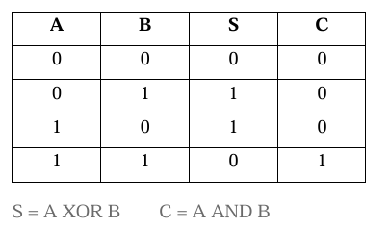

**OUTPUT**

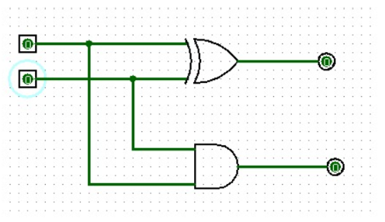

**RESULT**: Thus 2-bit half adder has been designed and implemented successfully using logisim simulator.

**TWO BITS HALF SUBTRACTOR**

**EXP.NO: 29**

**AIM**: To design and implement the two-bit half subtractor using Logisim simulator.

**PROCEDURE:** 1) Pick and place the necessary gates.

2) Insert 2 inputs into the canvas.

3) Connect the inputs to the OR gate, AND gate and NOT gate.

4) Insert 2 outputs into the canvas.

5) Make the connections using the connecting wires. 6) Verify the truth table

**TRUTH TABLE**:

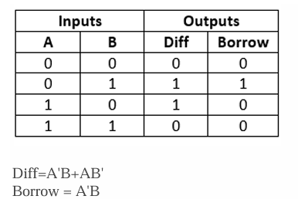

**OUTPUT;**

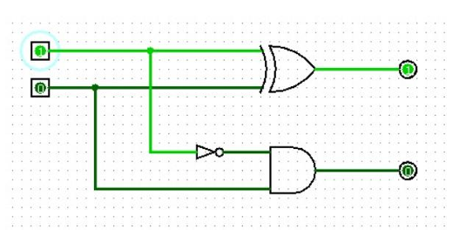

**RESULT:** Thus 2-bit half subtractor has been designed and implemented successfully using logisim simulator.

**FULL ADDER**

**EXP.NO: 30**

**AIM:** To design and implement the full adder using Logisim simulator.

**PROCEDURE**: 1) Pick and place the necessary gates.

2) Insert 3 inputs into the canvas.

3) Connect the inputs to the XOR gate, AND gate and OR gate.

4) Insert 2 outputs into the canvas.

5) Make the connections using the connecting wires.

6) Verify the truth table.

**TRUTH TABLE:**

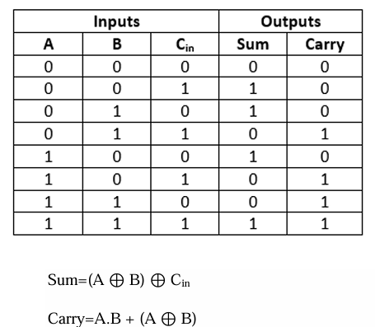

**OUTPUT;**

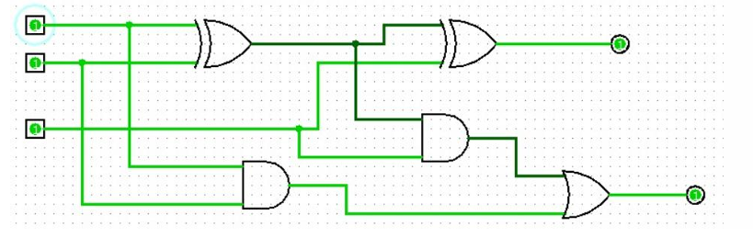

**RESULT:** Thus, full adder has been designed and implemented successfully using logisim simulator.

**FULL SUBTRACTOR**

**EXP.NO: 31**

**AIM:** To design and implement the full subtractor using Logisim simulator.

**PROCEDURE**: 1) Pick and place the necessary gates.

2) Insert 3 inputs into the canvas.

3) Connect the inputs to the XOR gate, AND gate and OR gate.

4) Insert 2 outputs into the canvas.

5) Make the connections using the connecting wires.

6) Verify the truth table.

**TRUTH TABLE:**

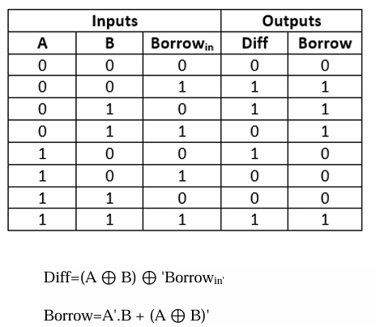

**OUTPUT;**

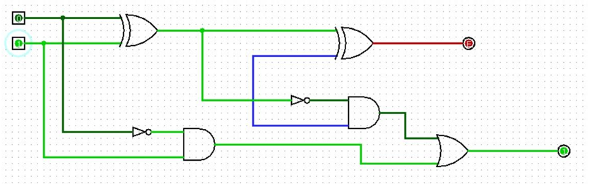

**RESULT:** Thus full subtractor has been designed and implemented successfully using logisim simulator.